**Database Topics**

1. Creating a table with some columns
2. Setting a Primary key (single column primary key and composite primary key)
3. Creating an Identity column
4. Creating a calculated column
5. Inserting some rows in a table, both from design view and using insert into script.
6. Creating a view
7. Using some built in functions like isnull, floor, ceiling, round etc.
8. String functions
9. Date time functions
10. Creating a user defined function
11. Creating a table valued function
12. Creating a stored procedure (with input parameters and output parameters)
13. Calling a stored procedure with output params
14. Creating a temporary table
15. Inner join, left outer join, right outer join syntax
16. Dynamic sql
17. Executing a dynamic sql
18. If else in sql
19. Sql case when statement
20. Sql aggregate function with group by clause
21. Pivot table, unpivot table syntax

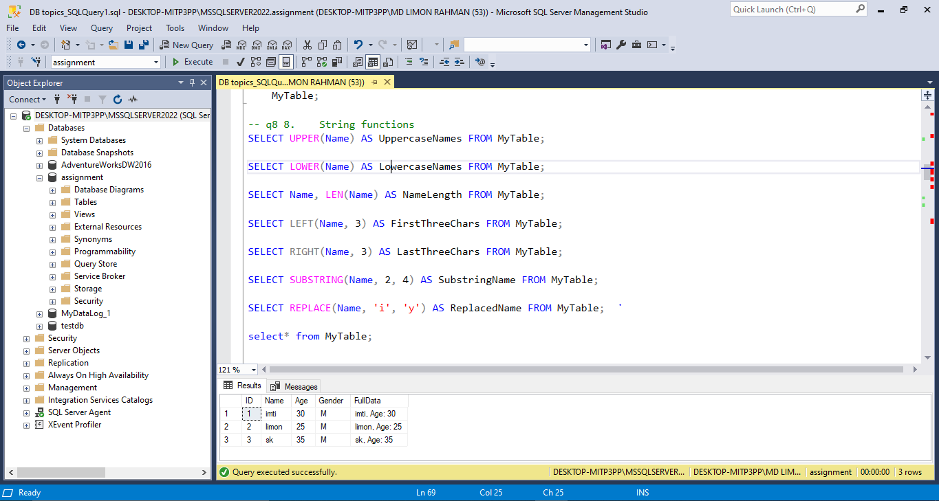

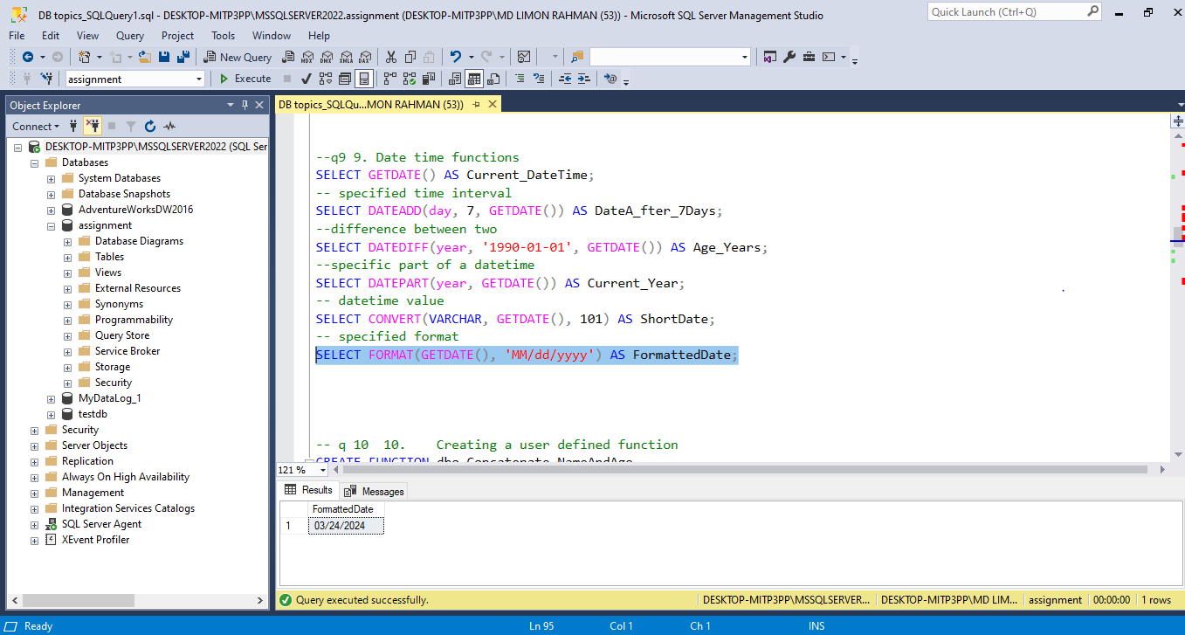

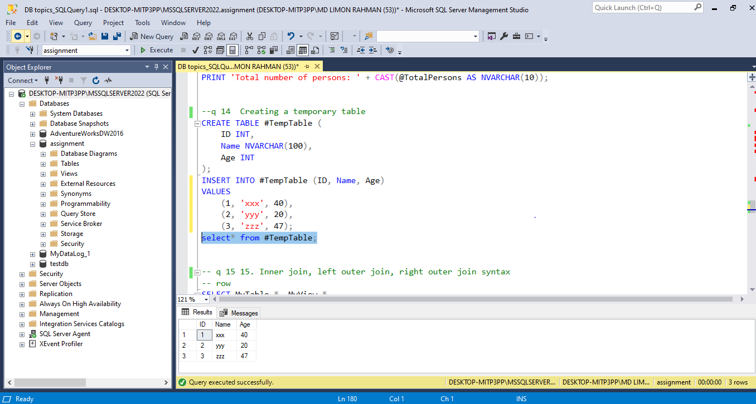

**Data Loading**

1. Loading csv data to database.

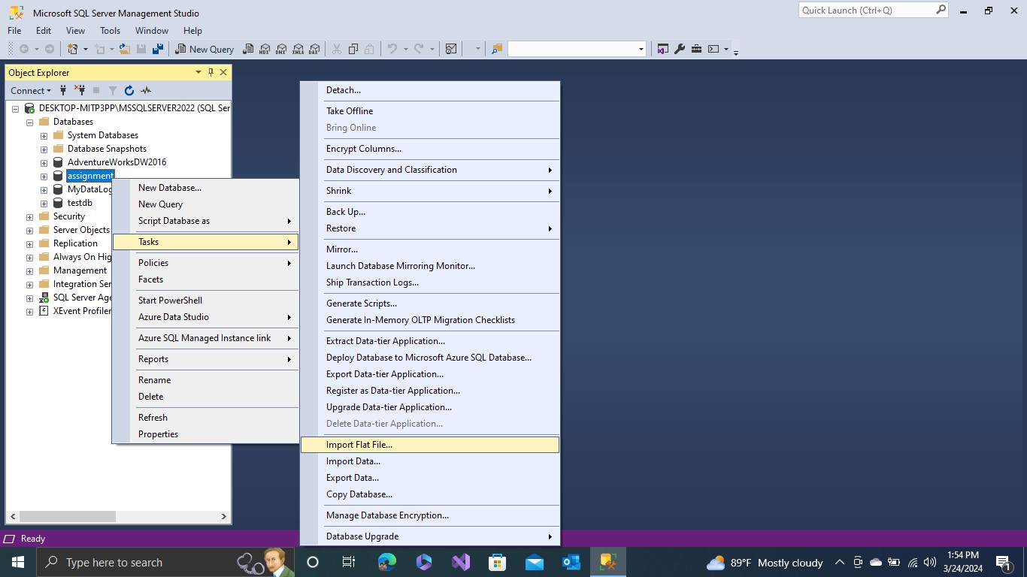

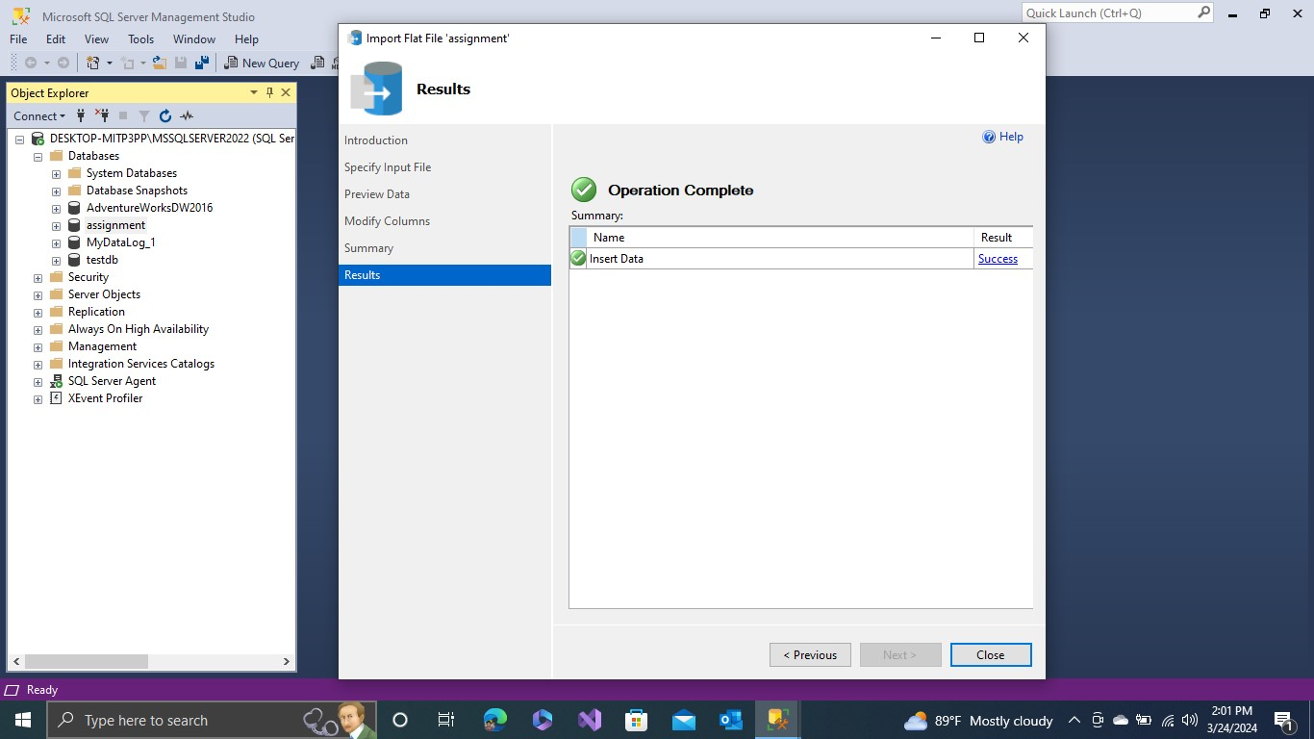

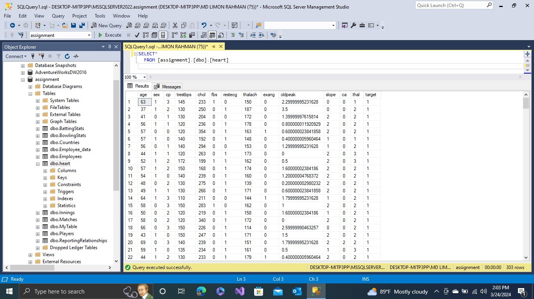

1. Loading excel data to database.

